IST 210 Section 003 - Team 1

Team Members: Daibo Zhang, Purna Bhattarai, Astan Doumbia, Ryan Carey

**GYM DATABASE SYSTEM (GDS)**

**Project Information**

This project is about a system that allows a business to keep track of memberships, employee information and client information. This system will allow employees to register new clients, membership purchases, and merchandise. This system will list sales for each day as well as track membership rewards. This system will store the list of employees and clients.

**The solution for problem solved by a database**

Scheduling conflicts are frustrating for both customers and employees. The way our requirements are structured will prevent these conflicts. Merchandise can be eliminated easily if it isn’t selling.

**Why your project is important?**

It is important because it will keep track of class locations and timeslots to prevent scheduling conflicts. The system will also keep track of employee and customer information and memberships, inventory and sales to streamline the operations of the business.

**Users of the System**

The system will be used by employees to track sales as well as the membership status of clients. It will also be used by employees to schedule clients for classes and prevent overbooking.

**Unique aspects of your Project**

The constraints against multiple classes in one location at any given time will prevent overbooking. Recording the date of sales will allow poorly sold items to be phased out proactively.

**Project Requirements**

The system should be easy to use by the end user. It should only require the entering of client purchases and only display the client bill, membership options, and scheduled classes. This database should be normalized.

**Entity Types and Attributes**

Entities: Client, MembershipPlan, FitClass, TimeSlot(Weak), Instructor, Merchandise, Location

**Client**: ID, Name, Phone, Address, email, activity status, reward points

**MembershipPlan**: ID, Name

**FitClass**: ID, Name, Instructor

**TimeSlot(Weak)**: FitClassID, Time

**Instructor**: ID, Name, Phone

**Merchandise**:ID, Name, Price, DateLastSold

**Location**: ID, Type, Number

A client can singnup for a membership plan. A membership plan can be subscribed by multiple clients.

A client can purchase multiple items (Merchandise). An item(Merchandise) can be purchased by multiple clients.

A client can register for multiple classes(FitClass). A class(FitClass) can be registered by multiple clients

An instructor can teach multiple classes(FitClass). A class(FitClass) can be taught by multiple instructors.

A class(FitClass) can held in one timeslot. A timeslot can hold multiple classes(FitClass)

A class can be held in multiple locations. A location can hold multiple classes.

A unique (location and timeslot) can hold one class. A class can be held at multiple unique (location and timeslot).

**Functionalities of the system:**

1. The system is going to update and store clients. Clients cannot be deleted but they can be set to inactive if they stop coming.
2. The system is going to store, update, delete membership plans. It cannot delete the membership plan if contains clients.
3. The system will store, update, and delete items. Each item will have a price. If a client has purchased an item, it cannot be deleted.
4. If an item has not been bought in the past period of time, the system will update the item with date of last purchase (DateLastSold)
5. The system will store, update, and delete the transactions for items items(merchandise). Each transaction will have a date of purchase, quantity.
6. The system will store, update, and delete client subscription of membership plans
7. The system will store, update, and delete client registration for classes. Each registration will have a date.
8. The system will store, update, and delete class assignment for instructors

IST 210 Section 003 - Team 1

Team Members: Daibo Zhang, Purna Bhattarai, Astan Doumbia, Ryan Carey

ER-Diagram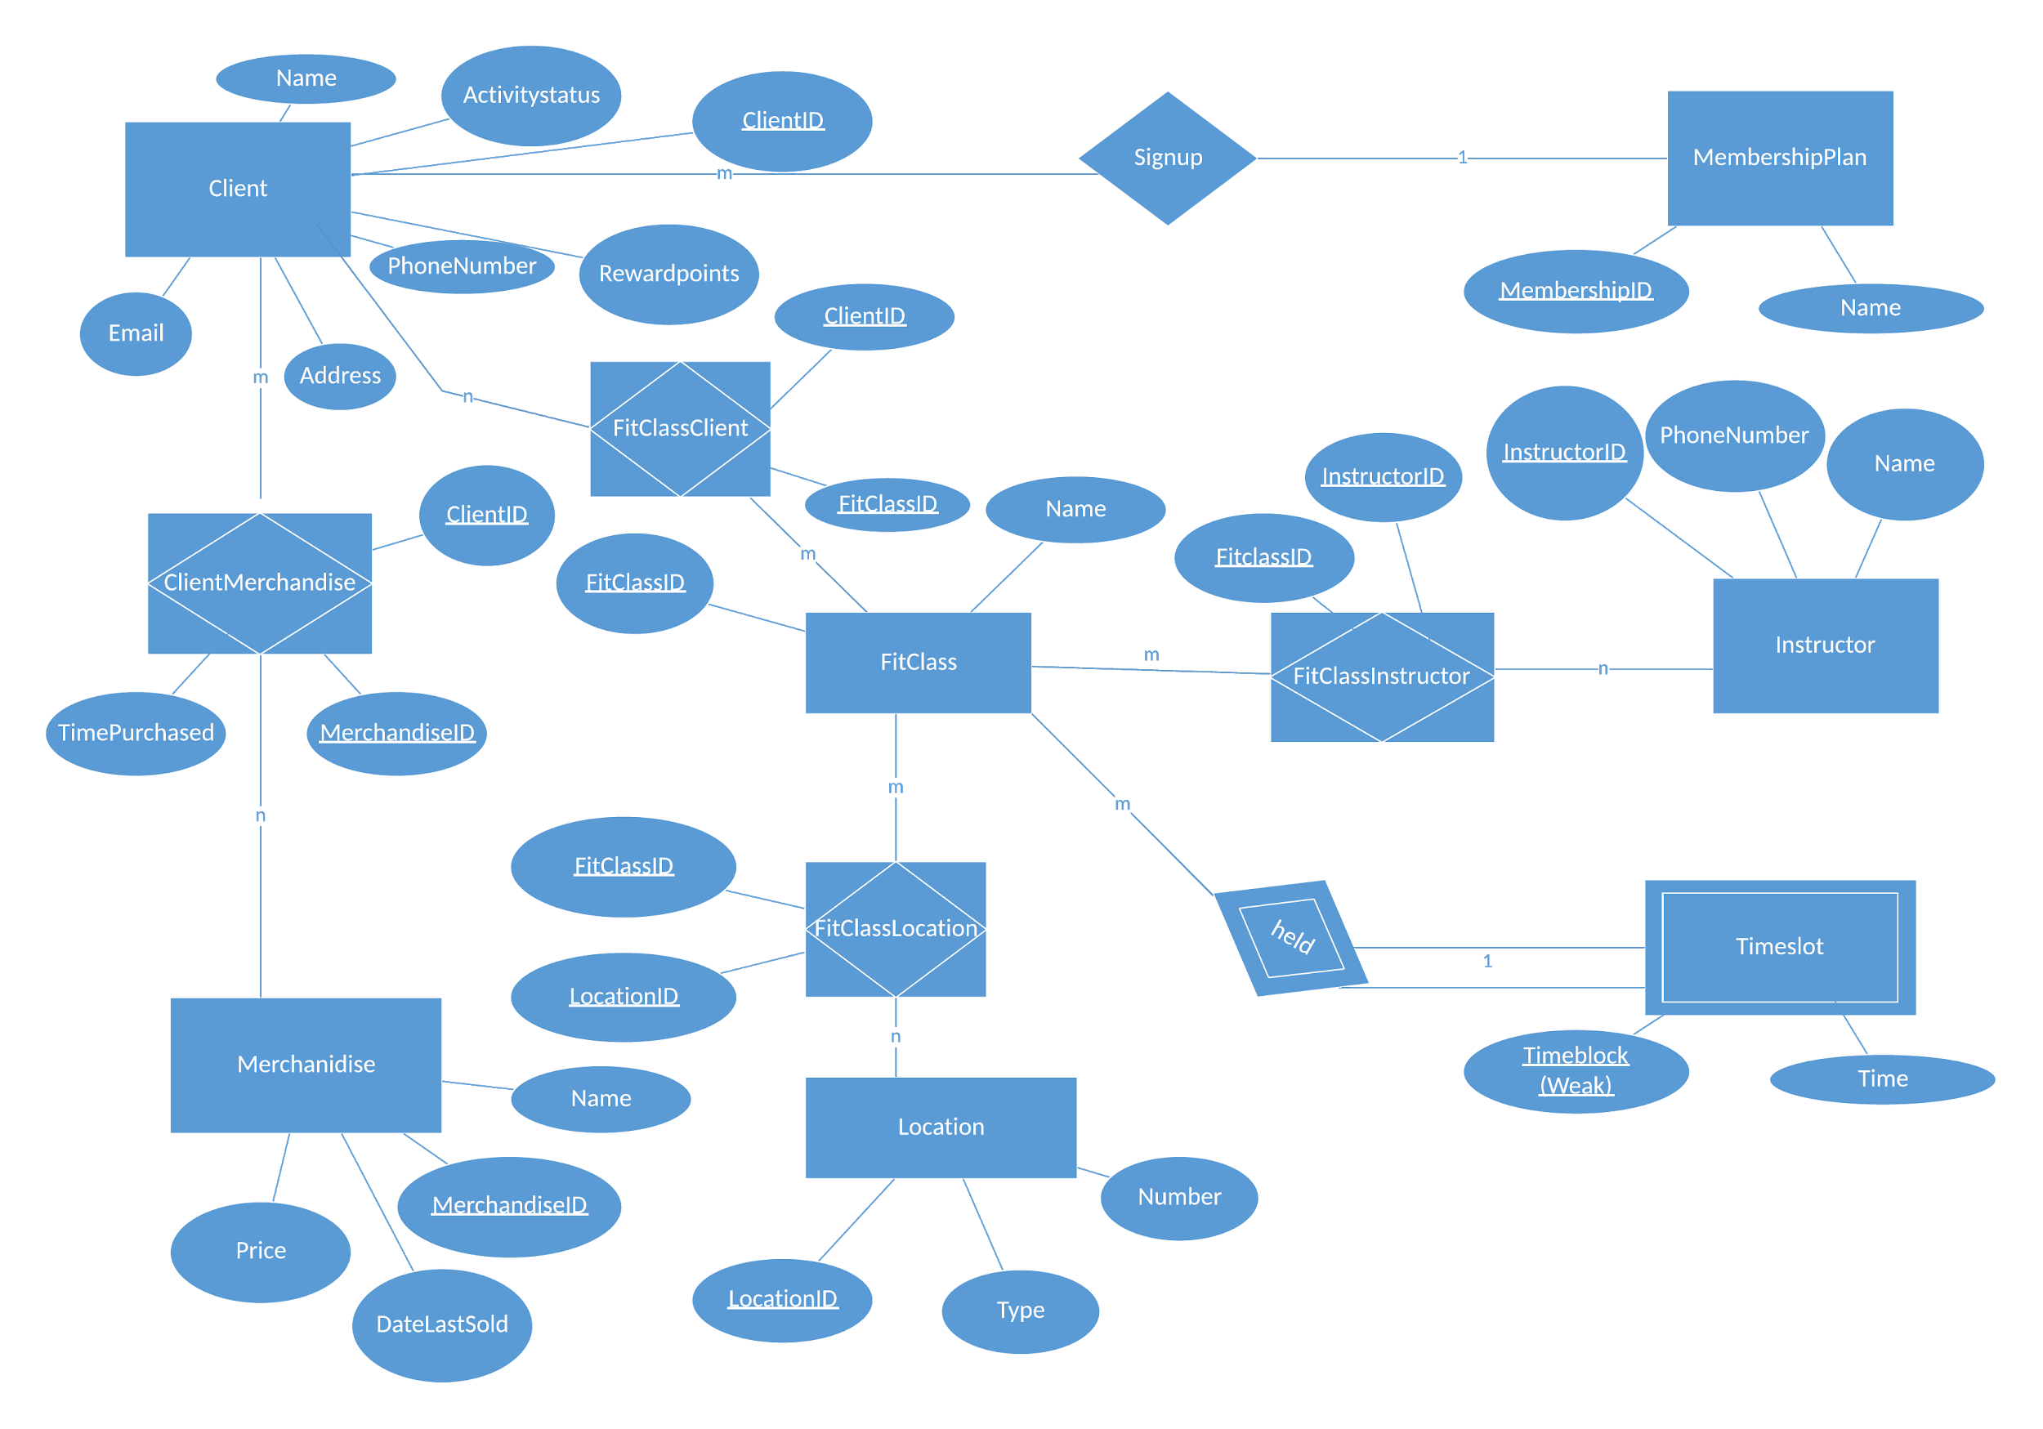

Comments about ERD: -1 point. Timeslot cannot be weak. It is on the "one" side of the relationship. In order to be weak, it has to be on the "many" side of the relationship. So timeslot is strong. Comments about Relationsal Schema: Fix the errors in ERD and re-do your relational schema as necessary. -1 point. FitClassID and InstructorID are PK in FitClassInstructor. When you make TimeSlot strong. It will have a table of its own. TimeSlot(Timeblock, Time) Also you will make Timeblock as a FK in FitClass table.

Translation method: Mapped  
Relational schema:

Client (ClientID, MembershipID*, ActivityStatus, Name, PhoneNumber, Address, Email, Rewardpoints)

MembershipPlan (MembershipID, Name)

ClientMerchandise (ClientID*, MerchandiseID*, TimePurchased)

Merchandise (MerchandiseID, Name, Price, DateLastSold)

FitClassClient (ClientID*, FitClassID*)

FitClass (FitClassID, Name)

Timeslot (FitClassID*, Timeblock, Time)

FitClassLocation (FitClassID*, LocationID*)

Location (LocationID, Number, Type)

FitClassInstructor (FitClassID*, InstructorID*)

Instructor (InstructorID, Name, PhoneNumber)